

SUPERIOR UNIVERSITY LAHORE
GOLD CAMPUS

NAME: MUHAMMAD MOIZ RAZA
ROLL NO: SU92-BSAIM-F24-061
PROGRAM: ARTIFICIAL INTELLIGENCE
SEMESTER: 4th SEMESTER
SECTION: BSAI-4A
SUBJECT: PROGRAMMING OF AI (LAB)

Submission Title: LAB TASK 2
Submitted To: Sir Rasikh Ali

TITLE: Data Preprocessing and Random Forest Model for Transported Prediction

OVERVIEW:
A basic machine learning workflow using a dataset stored in train.csv. The notebook performs data preprocessing, exploratory data analysis, and classification using a Random Forest model. The goal is to prepare the data, train the model, and predict whether a passenger is Transported or not.

Technologies Used

Backend / Processing
- Python
- Pandas
- Scikit-learn

Visualization
- Matplotlib
- Seaborn
Model Train
- RandomForest

Model Saving
- Pickle

FEATURES :
It includes data loading, data inspection, missing value handling, and categorical encoding. It also provides visual analysis using graphs and trains a Random Forest machine learning model to make predictions. Finally, the trained model is saved so it can be reused without retraining.

Working:
First loads the dataset and explores its structure using pandas. It then handles missing values, encodes categorical variables, and visualizes the data using graphs. After preprocessing, the dataset is split into training and testing sets. A Random Forest classifier is trained on the training data, predictions are made on the test data, and the trained model is saved as a .pkl file for future use.
Uses:
This is useful for understanding the machine learning pipeline, including data preprocessing, visualization, model training, and model saving. It can be used as a learning example for students or as a starting point for building more advanced predictive models.
Screenshot:
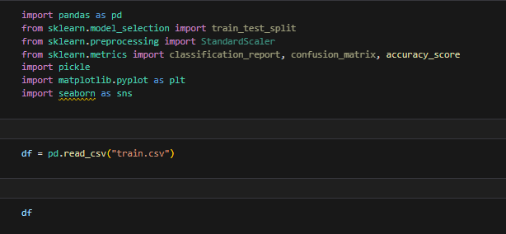
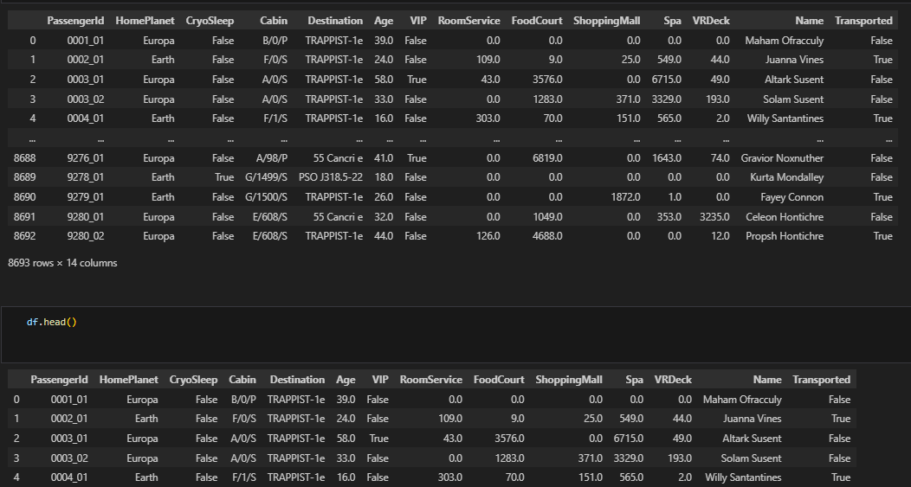
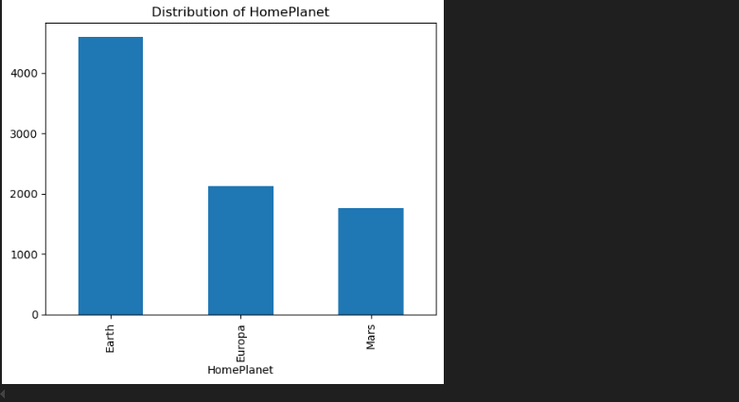

THE END

